How to make a graph in Google Docs

- In Google, search for google spreadsheet
- Select google spreadsheet

- Add titles to the first two columns
- Type in your data

- Highlight your data

- Select the insert tab and select chart
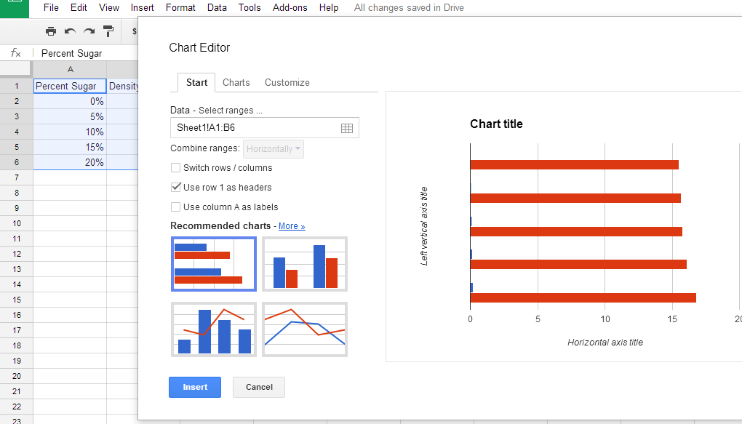
- Click on the charts tab and select scatter and chose the icon on top with the red and blue dots
- Click Insert

- Two finger tap anywhere on the chart (the white box with the graph in it) and the drop down menu. Then Click on advance edit

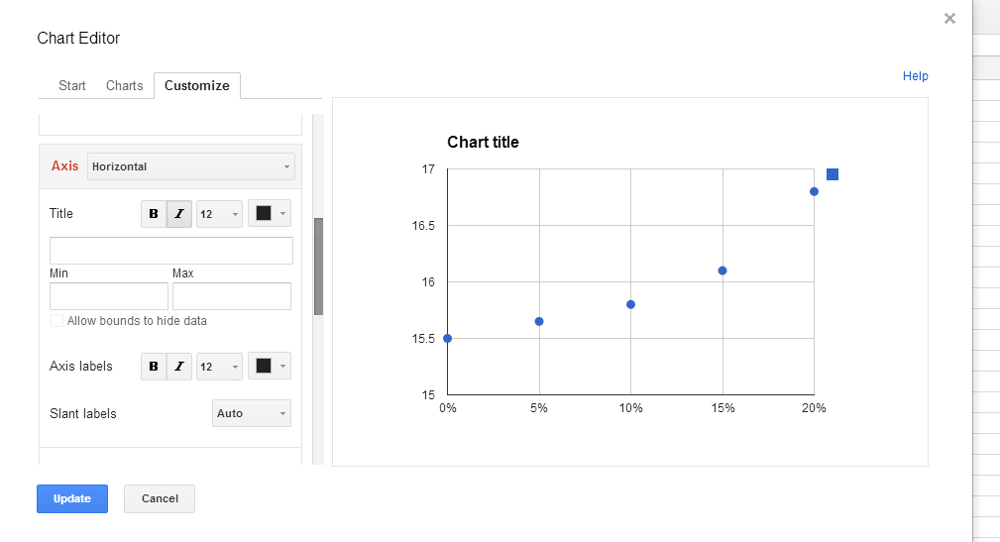
- Use the customize tab to add a title and label the axis
You will need to scroll down to add in the labels for x and y

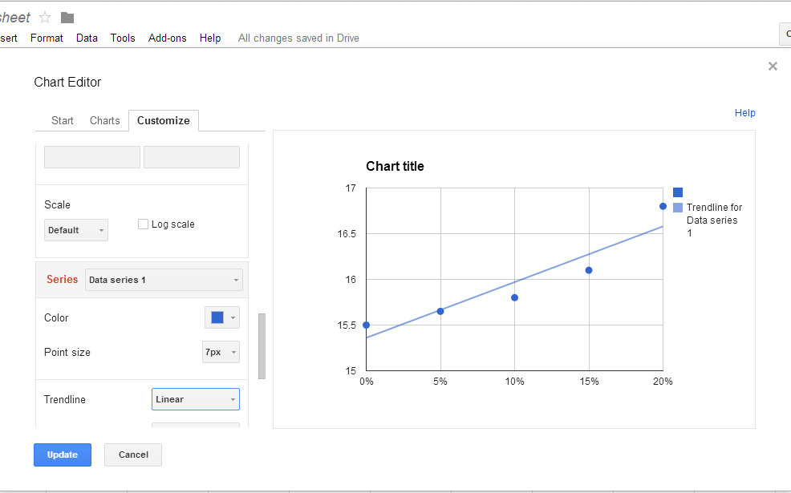
- Scroll down to the bottom to add a linear trendline
- Scroll your mouse over the trendline (best-fit line) and write down the equation. It should be in the form (y=#x + #). Do not include the bold number after the colon. They are coordinates.
- Click update

- Save and Print or Save and Share

