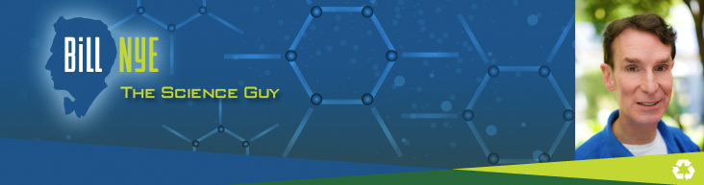
Congratulations! You have been hand-selected by Bill Nye himself to write, direct, and star in the next episode of “Bill Nye the Science Guy”!! Below are directions as dictated by network producers. Good luck!
Basic Directions:
- You will be making a Bill Nye episode on a chemistry topic of your choice (must be pre-approved).
- You may work alone or in groups of 2 or 3 (no more than 3).
- Your episode should be at least 6 minutes long.
- You will have a small amount of time to work on this in class. Most of the time will be spent on planning your video. You may schedule an appointment afterschool to use my classroom as your movie set.
What needs to be in your episode:
Your episode should begin with:
- An introductory situation/commercial/tv clip/etc.
- Your show’s theme song – you may use the original theme song or make up your own
Within the episode, you should explain the facts and concepts of your topic in short (~10-30 seconds) intervals. Mixed in with the facts should be the following segments (you must do at least 4):
- Nifty home experiment – an experiment that can be done at home with normal household equipment and materials
- Way cool scientist – a scientist that is doing something as a job related to your topic
- Consider the following - describes an argument with two opposing viewpoints or a piece of information that might be surprising
- Did you know that? – a short quick fact about your topic
- Music video – remake a current song with words related to your topic and perform the song
(Students who sing or rap in the video may receive extra credit- depending on the quality of the song)
- An advertisement/commercial for a product/service/company related to your topic
- A fake TV show related to your topic

Suggestions from the producers:
Bill Nye is the funniest person who works on our network, so make your videos funny! He is also LOUD. Be outrageous! Check YouTube for past episodes of Bill Nye the Science Guy for inspiration, or to figure out what the segments above should look like. We can’t WAIT to see your video!

Members of Group (up to 3): _______________________________________________________________________
_______________________________________________________________________
_______________________________________________________________________

**One person in each group is required to submit this paper on the three different due dates listed below**

Topic due: ___________________________________________

Topic Chosen: _____________________________________________________________ Approval: ___________________________________________

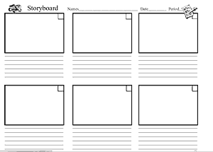
Storyboard due: ________________________________________

Storyboard: This is a basic outline of the segments and the order they will go in your video. You may use a storyboard template found online similar to the one shown or the website: www.storyboardthat.com

Final Project due: ______________________________________

Grading – This is worth a 100 point exam grade
____/50 – Accuracy of information
____/30 – Inclusion of all parts of a Bill Nye episode
____/10 – Video quality
____/10 – Creativity and originality
____/100 – Final score

